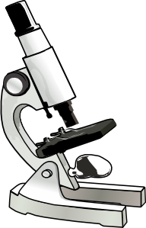
Year 10 Biology
Microscope Assessment

Name ________________________

For this task you will be assessed on your technical skill and your knowledge about using microscopes.
You need to get your teacher to check your efforts at the end of the first three parts below.

You need to prepare a Plant Cell (onion) slide. (2 marks)

Then set up a microscope. (1 mark)

Focus on the cells at 100 times magnification (1 mark)

And then complete the following:

- Draw a diagram of the cells you saw. (2 marks)

- Explain why it is necessary to stain cell preparations. (2 marks)

- Describe and explain the process for focusing on a slide. (2 marks)

